

ÇUKUROVA UNIVERSITY

FACULTY OF ENGINEERING
MULTI-DICIPLINARY ENGINEERING PROJECT
INTERIM REPORT
PROJECT TITLE

STUDENT NUMBER - NAME
STUDENT NUMBER - NAME
STUDENT NUMBER - NAME
STUDENT NUMBER - NAME
STUDENT NUMBER - NAME
STUDENT NUMBER - NAME
STUDENT NUMBER - NAME
STUDENT NUMBER - NAME
STUDENT NUMBER - NAME
STUDENT NUMBER - NAME
STUDENT NUMBER - NAME
STUDENT NUMBER - NAME
STUDENT NUMBER - NAME
STUDENT NUMBER - NAME
STUDENT NUMBER - NAME

ADVISORS
ASST. PROF. OĞUZHAN TİMUR
ASST. PROF. ŞAFAK NESLİ

DECEMBER
2025
ADANA
PROJECT ABSTRACT
Write your abstract here. The abstract must not exceed 500 words and should provide a concise summary of the study, including its purpose, methodology, main findings, and conclusions. A maximum of five keywords may be listed, and both the abstract and keywords must fit within a single page.

Keywords:

CONTENTS
 | Page
PROJECT ABSRACT | i
CONTENTS | ii
ABBREVIATIONS AND SYMBOLS | iii
LIST OF TABLES | vi
LIST OF FIGURES | v
1. PROJECT INTRODUCTION | 1
2. PROJECT TOPIC | 3
3.PROJECT MATERIALS | 5
3.1. Example Section 1 | 5
3.1.1. Example Section 2 | 5
3.2. Example Section 3 | 5
4. POTENTIAL CONTRIBUTIONS TO THE INDUSTRY | 7
ACKNOWLEGEMENT | 9
REFERENCE | 11
ABOUT THE AUTHORS AND AUTHOR CONTRIBUTION | 13
APPENDIX | 15

ABBREVIATIONS AND SYMBOLS
TC | Türkiye Cumhuriyeti – Republic of Turkey
CNN | Convolutional Neural Networks

LIST OF TABLES
Table | Page
Table 1.1. Example Table | 1

LIST OF FIGURES
Figure | Page
Figure 1.1. Example Figure | 1

1. PROJECT INTRODUCTION
In this section, you should begin by presenting the general context of the subject you have studied. Then, briefly discuss the current state of research or applications related to your topic, followed by a concise literature review. Next, provide a short overview of your project, highlighting its scope and objectives. Finally, conclude the introduction with a paragraph that outlines the overall structure of the report.
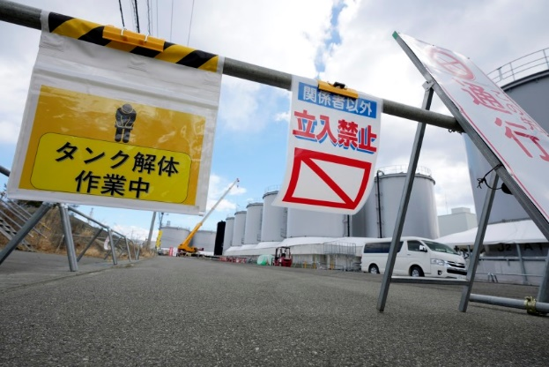
Figure 1.1. Example Figure.

There must be one blank line both before and after figures and tables.

Table 1.1. Example Table.
Column 1 | Column 2
Row 1 | Row 1
Row 2 | Row 2

2. PROJECT TOPIC
This section should provide an analysis of previous studies and research related to the chosen subject.

3. PROJECT MATERIALS
In this section, you should describe in detail the materials and methods used to carry out your project. This includes datasets, hardware, software, tools, and techniques applied during the study.
3.1. Example Section 1
3.1.1. Example Section 2
3.2. Example Section 2

4. POTENTIAL CONTRIBUTIONS TO THE INDUSTRY
In this section, you should present the outcomes of your study in a clear and systematic manner. Describe the results obtained by applying the methods outlined in the previous section, including any modifications or improvements you introduced. Support your findings with appropriate figures, tables, or other visual materials where necessary. Following the presentation of results, provide a discussion that interprets their significance, evaluates their effectiveness, and compares them with existing studies or approaches. Highlight the strengths, limitations, and potential implications of your work.

ACKNOWLEGEMENT
In this section, you should acknowledge any individuals, institutions, or organizations that contributed to the completion of your study. If your project received financial or institutional support from programs such as BAP (Scientific Research Projects), TÜBİTAK, or other funding bodies, this must be clearly stated. You may also express gratitude to your advisors, colleagues, or anyone else who provided significant assistance during the project.

REFERENCE
This section lists all the sources cited in your report, formatted according to APA 7th edition guidelines. Each entry should be presented with a hanging indent, meaning the first line is flush left, and all subsequent lines are indented by 1,25 cm. Entries should be alphabetized by the surname of the first author. Ensure that all cited works are included, and all listed references are cited within the text.
Smith, J. A. (2020). Understanding artificial intelligence: Concepts and applications. TechPress.
Doe, J. B., & Lee, C. D. (2019). Machine learning algorithms in healthcare: A review. Journal of Medical Informatics, 45(3), 123-135. https://doi.org/10.1016/j.jmedinf.2019.01.003
National Institute of Standards and Technology. (2021, March 15). Cybersecurity framework. https://www.nist.gov/cybersecurity-framework

ABOUT THE AUTHORS AND AUTHOR CONTRIBUTION
In this section, provide a brief description of each author and their specific contributions to the study. Each author should be described in a separate paragraph. Include information such as academic background, role in the project, tasks performed, and any special expertise or responsibilities that were critical to completing the work. This ensures transparency and proper recognition of individual contributions.

APPENDIX
Appendices include extra material that supports your report but is too detailed to place in the main sections. Each appendix should be labeled with a letter (e.g., Appendix A, Appendix B) and a descriptive title. Refer to the appendix in the text where relevant.
Examples of content you might include in appendices:
-Raw Data: Full datasets, survey results, or measurement logs that were summarized in the Results section.
-Figures and Tables: Additional charts, graphs, or tables that support your analysis but are too large for the main text.
-Questionnaires or Interview Scripts: Copies of surveys or interview questions used in your study.
-Code or Algorithms: Scripts, formulas, or technical procedures used in your project.
-Supplementary Documents: Manuals, instructions, or reference materials referenced in your report.
Example Format in the Appendix Section:

Appendix A: Survey Questionnaire
The questionnaire used to collect responses from participants is presented below.

Appendix B: Full Dataset
The complete dataset used for analysis in the Results section is provided in CSV format.

Appendix C: Additional Figures
Figures showing extended analysis results not included in the main text.

